Accessing Archived Data Reported to IPEDS
Created by CSU’s Office of Institutional Effectiveness & Research, and Data Analytics, 7/6/22
Updated 12/21/23

Step 1.
Put this URL into your search bar: https://nces.ed.gov/ipeds

Step 2.
Click “Use The Data”, and “Lookup an Institution”
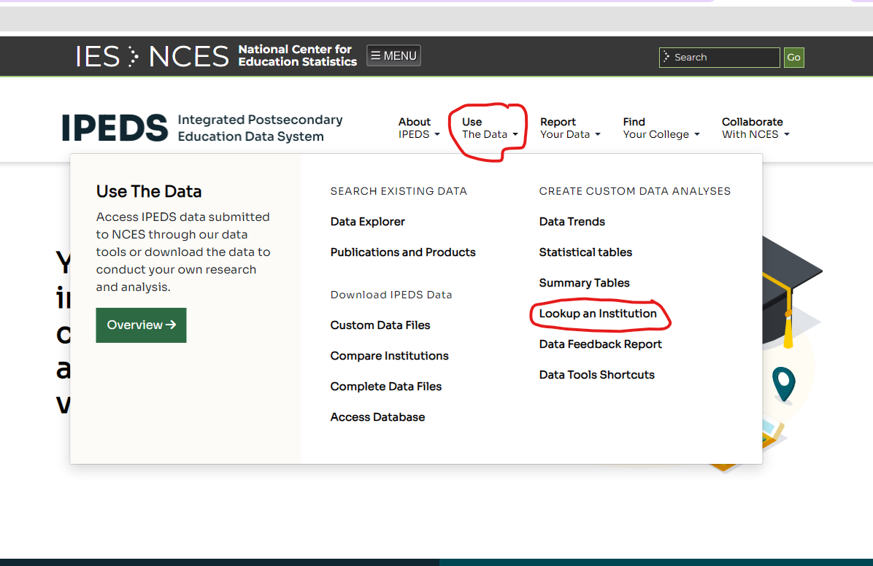

Step 3.
Type Chicago State University in the Institution Name box. Click Select.
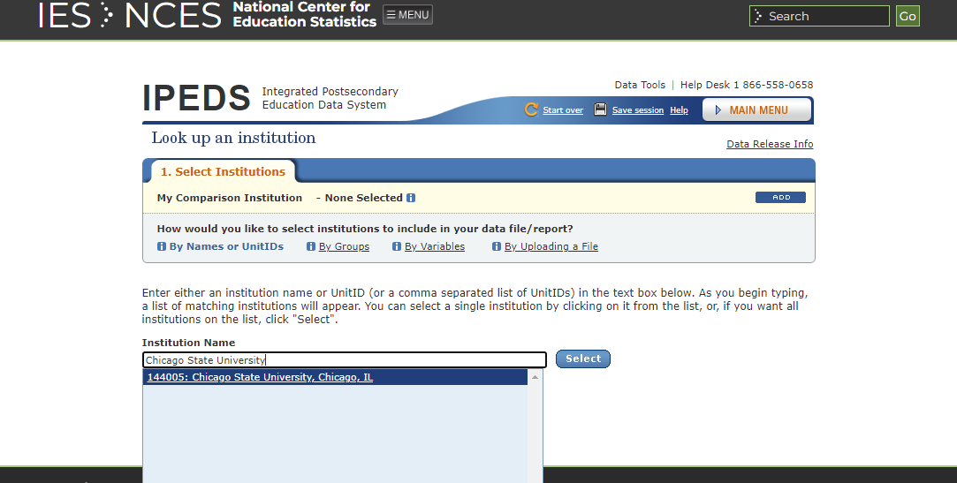

Step 5.
Click Chicago State University under Select Institution
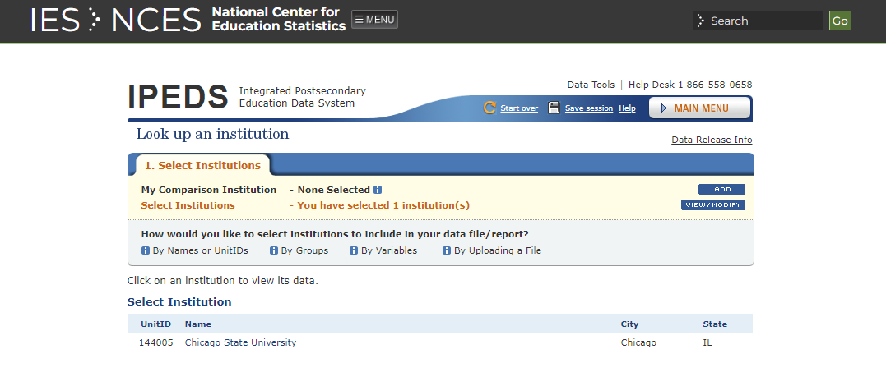
Click here

Step 6.
Click Reported Data to view data reported in prior years.
Click here
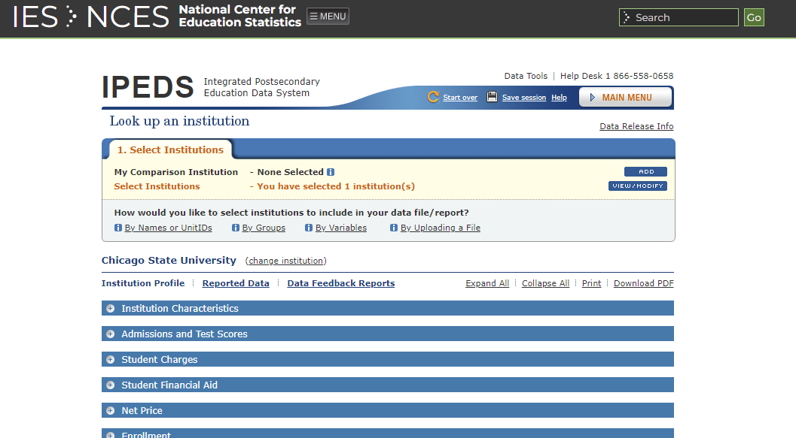

Step 7.
Select the topic that you’re interested in.

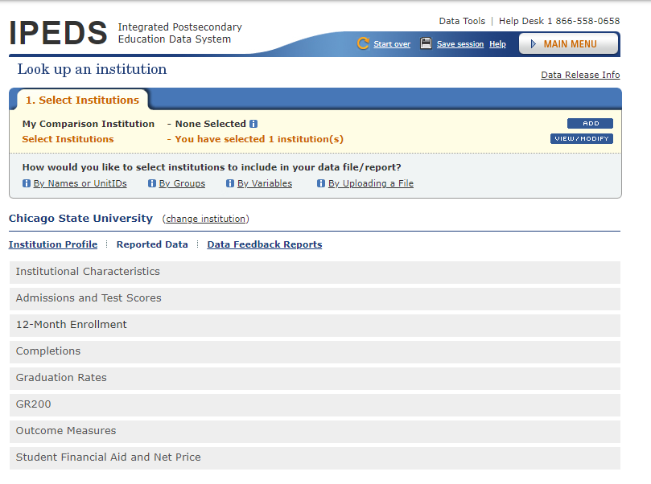
Select a topic

Step 8.
Select the Year and/or modify the topic (i.e., Survey).
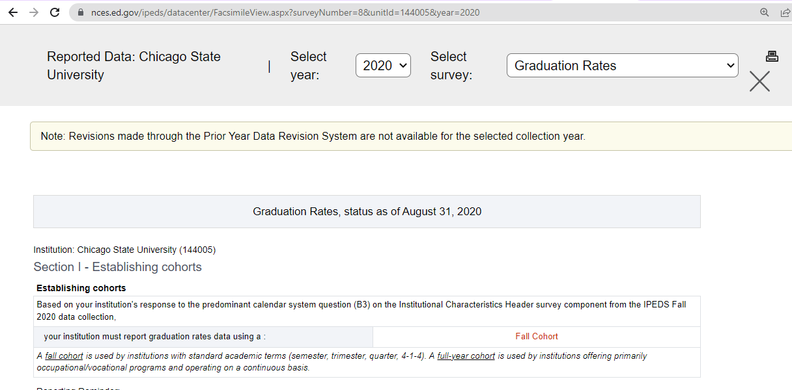
Click here to modify topic
Click here to select year

