# **Accessing Archived Data Reported to IPEDS**

Created by CSU’s Office of Institutional Effectiveness & Research, and Data Analytics, 6 July 2022

**Updated 8 Aug 2024**

## Step 1.

Put this URL into your search bar: <https://nces.ed.gov/ipeds>

## Step 2.

Click “Use The Data”, and “Lookup an Institution”

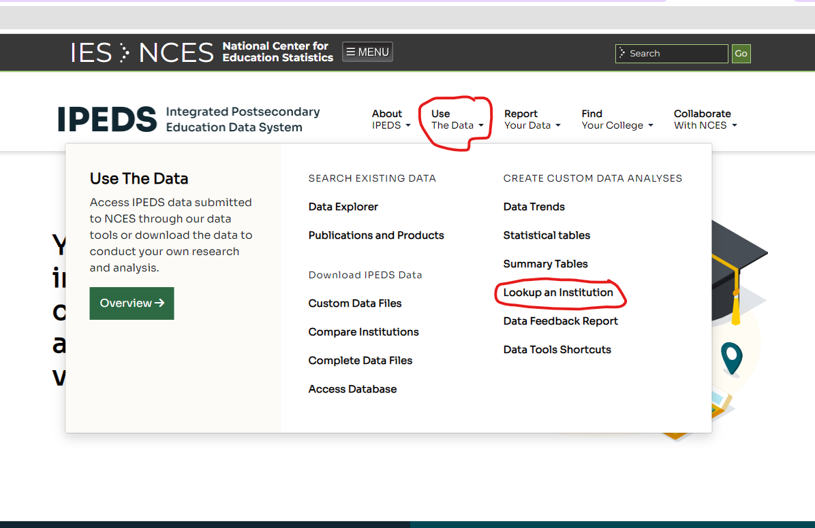

## Step 3.

Type *Chicago State University* in the Institution Name box. Click *Select*.

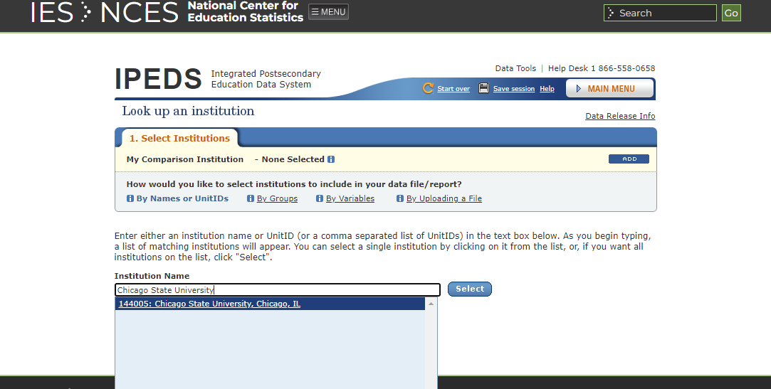

## Step 5.

Click Chicago State University under Select Institution

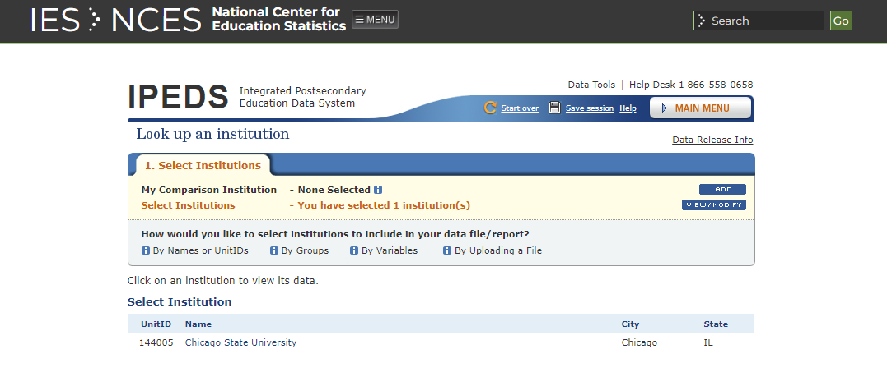

**Click here**

## Step 6.

Click **Reported Data** to view data reported in prior years.

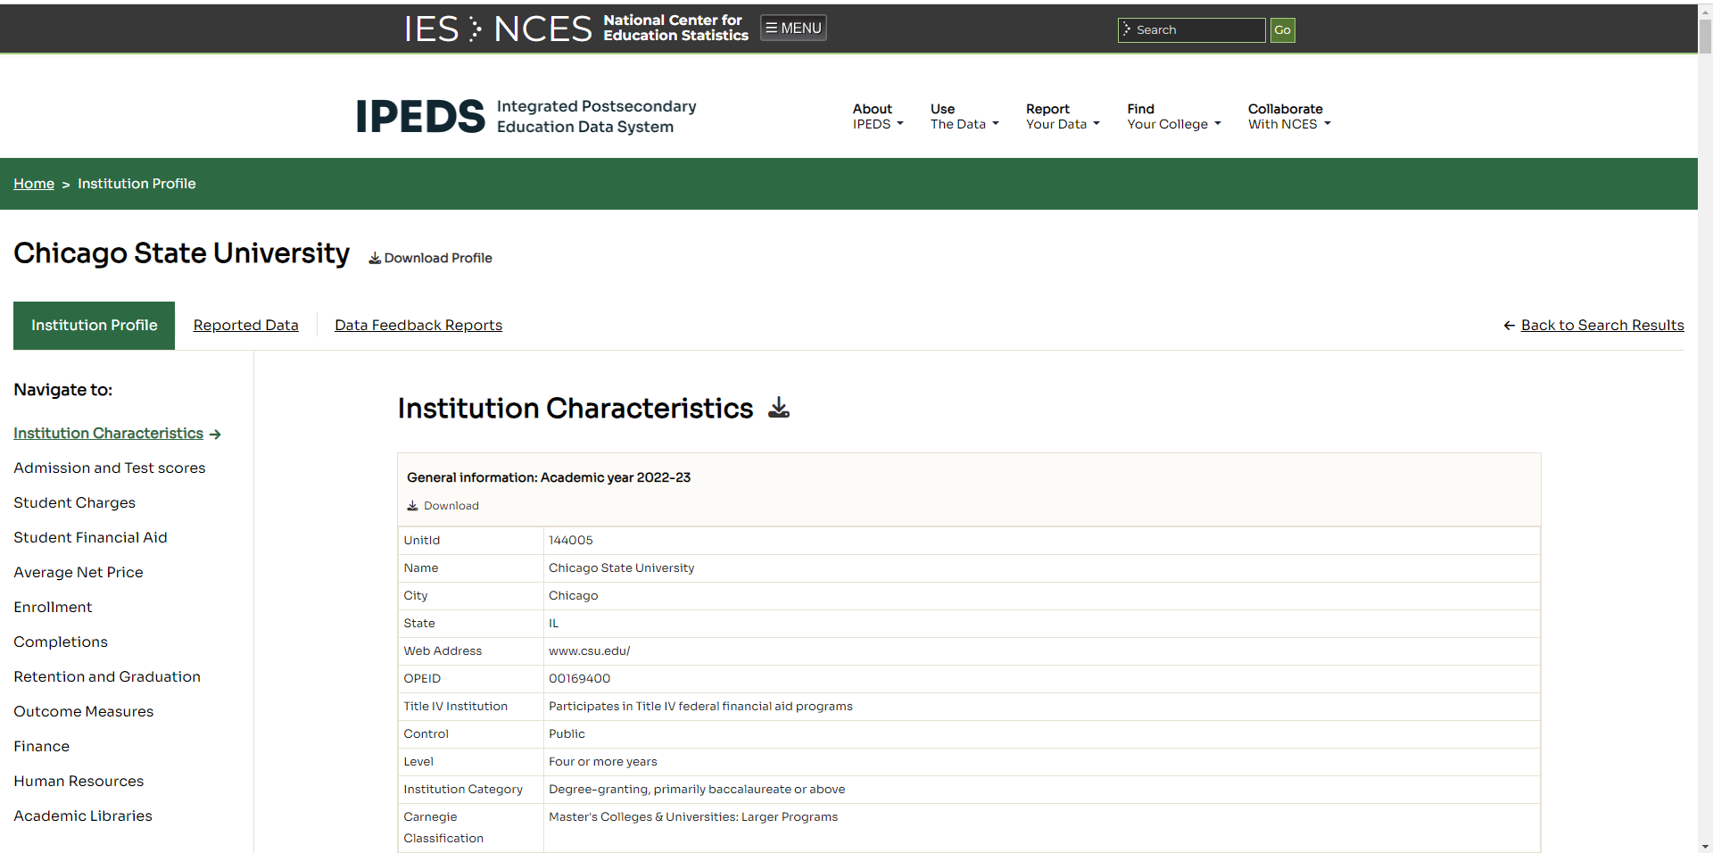

**Click here**

## Step 7.

Select an Academic Year and a Topic (i.e., Survey) that you’re interested in:

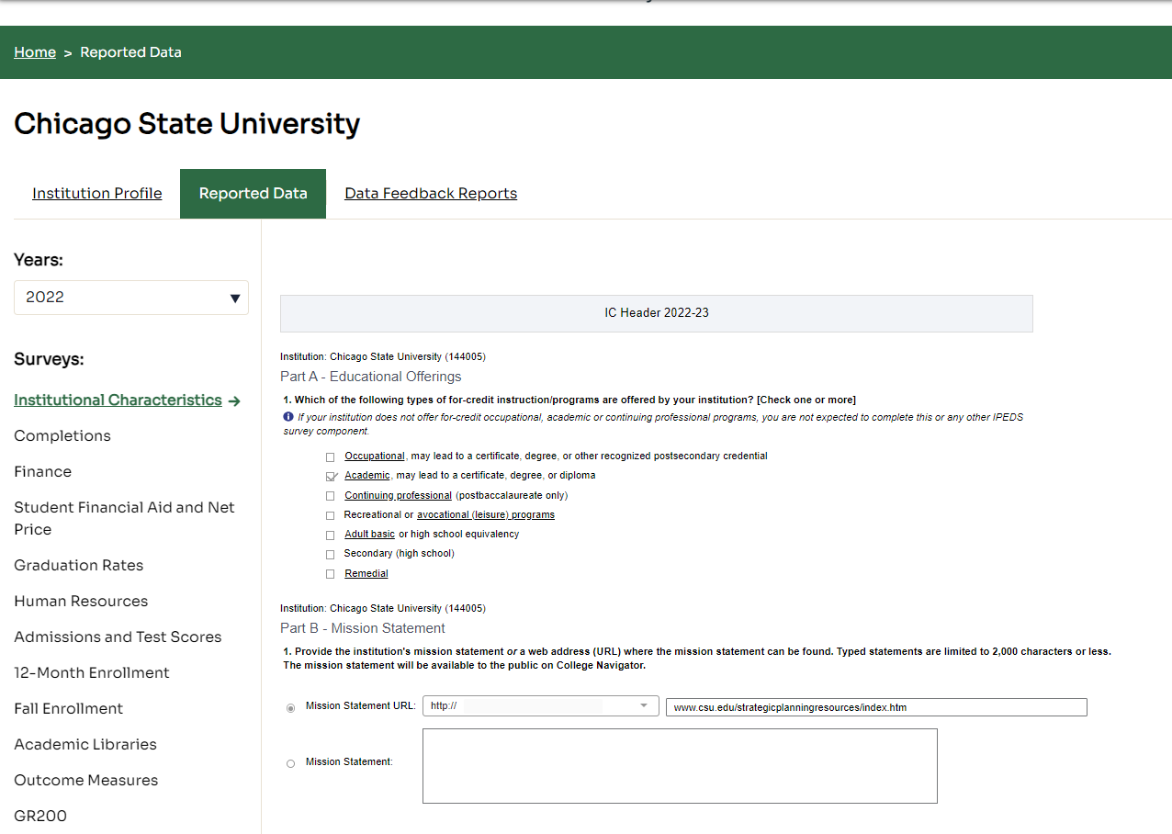

**Select a topic**

**Select a year**